System of geo-information mapping of debris flows hazard in the southern Baikal region
V P Stupin, L A Plastinin, B N Olzoev

Irkutsk National Research Technical University, Russia

E-mail kosmos@istu.edu
Abstract. The paper considers the principles and methods of GIS-mapping of debris flows based on the concept of morphological system, materials of remote sensing and geo-information technologies. It presents different results of geo-information mapping of debris flows in the southern Baikal region. The paper also justifies the need to use three components in mapping and monitoring of mudflow hazards as the integrating principle.
1. Introduction
At present, geo-information systems (GIS) are widely used around the world in different areas. It is beyond argument that the application of GIS technologies…
2. Materials and methods
The study is based on the Landsat-8 satellite images of 2017-2018…
3. Results and analysis
Debris flows suddenly appear under certain conditions, act a short period of time and are energy-intensive and destructive. The origin, type and character of debris flows define three groups of factors: climatic and landscape (meteorological factors, recent glaciation, soil permafrost, soil and vegetation cover), geological and geomorphological (composition of rocks, neotectonics, relief, recent volcanism, seismicity) and anthropogenic (deforestation, overgrazing, slope plowing, mining production, industrial and civil engineering). The first defines the mudflow zonation and mode (duration and calendar terms of a mudflow period). The second group accounts for the volume and length of mass transport of mudflows, material composition and rheological types of debris flows. The third group defines the activity of debris flows and the area of mudflow territories.
Genesis, density of debris flow network, their volume and recurrence belong to the main mapped characteristics of mudflow hazards. The three last characteristics allow assessing the mudflow intensity. The display system of these key characteristics in all direct or integral maps ensures continuity of a plotting scale, as well as consolidation and comparison of maps. GIS implies four levels of mudflow maps.
1. Detailed (1:10 000 and larger scale) engineering and design maps and diagrams for certain operating and potential torrential basins and mudflow observation stations. They are aimed at protection measures and mudflow observation stations.
2. Large-scale (1:25 000-1:50 000) design maps and diagrams of mudflow regions. They are aimed at protection measures and monitoring of debris flows. They are based on the morphology of mudflow basins and streams.
3. Mid-scale (1:200 000-1:500 000) evaluation maps and diagrams of certain regions. They display the typology of mudflow basins and form the basis for mudflow hazard cadastral plans and databases.
4. Small-scale (1:1 000 000 and smaller scale) general scientific and reference maps and diagrams of states, continents and the world. They display the dominating genetic types of debris flows and mudflow intensity.
…
4. Discussion
Let us explain the principles of mid-scale mapping of debris flows using the map of a part of the southern macroslope of Tunkinskaya Range. This morphological system is located between the main watershed of the ridge and its bottom providing exits (old riverbeds) of its basin subsystems and basal facets of Tunkinsky end tail. The order of water currents forming these basin systems varies within I-IV, however the map shows only those basin subsystems, which are directly based on a source system without displaying any affiliated and elementary basins, which is implied by morphological system mapping. Besides water-parting lines of the displayed basins, the map shows their old riverbeds representing direct, temporary and disappearing water currents, historical debris flows (100-150 years old) revealed through satellite images according to light lines, as well as residential territories (Figure 1).
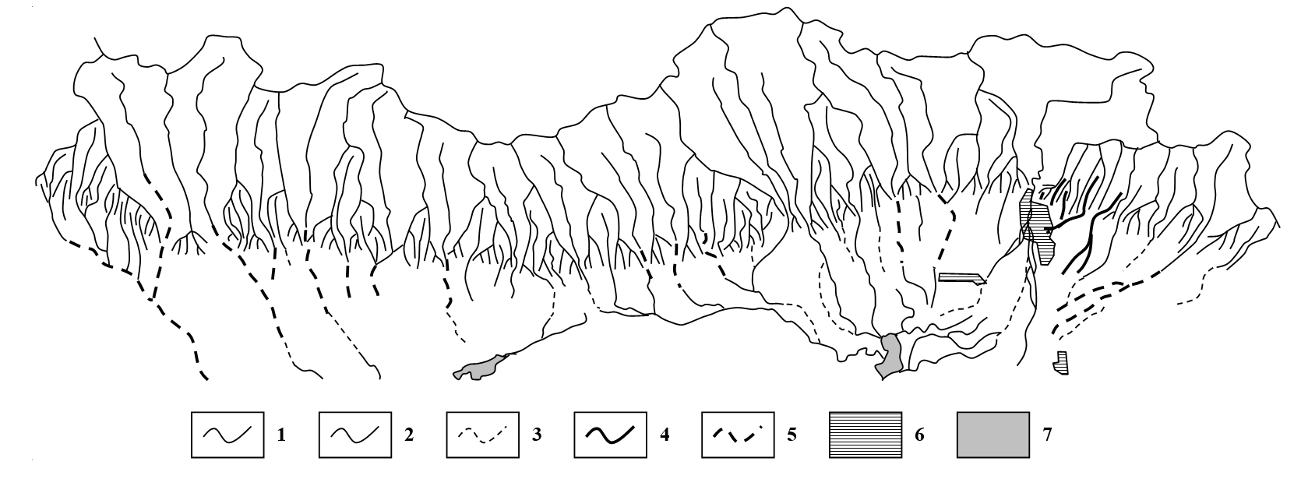
1 – mountain ridges (watersheds) of drainage basins; 2 – old riverbeds of continuous water with potential debris flows; 3 – old riverbeds of temporary and disappearing (subsurface) water currents with potential debris flows; 4 – debris flows 28.06.2014; 5 – debris flows of historical time (not more than 100-150 years old); 6 – residential territories (settlements); 7 – lakes.
Figure 1. Scheme of mudflow exposure in the northern side of the Tunka Depression.
5. Conclusions
The considered GIS-mapping of mudflow hazards is designed for further study and analysis of mudflow hazards in the southern Baikal region, for setting new research tasks, model and forecast the debris flows, develop measures to protect the population and technical objects in the coastal zone of the Lake Baikal. It can also be used by various administrative, scientific and production organizations for on-line assessment of mudflow hazards and urgent administrative decision-making.
References
- Perov V F 1996 Debris flows: dictionary of technical terms. (M.: Moscow State University)
- Rogozin A A 1993 Coastal zone of the Baikal and the Khubsugul (morphology, dynamics and history of development). (Novosibirsk: Nauka. Siberian Branch)
- Laperdin V K, Kachura R A 2010 Geodynamics of hazardous processes in zones of natural and technogenic complexes of Eastern Siberia. (Irkutsk: Institute of the Earth’s Crust, SB RAS)
- Laperdin V K, Imayev V S, Verkhozin I I, Kachura R A, Imayeva L P 2011 Geological hazards in the south of Yakutia and adjacent territories. (Irkutsk: Institute of the Earth’s Crust, SB RAS)
- Makarov S A 2012 Debris flows of the Baikal region. (Irkutsk: V.B. Sochava Institute of Geography, SB RAS)
- Belousov V M, Bude I Yu, Radziminovich Ya B 2000 Physical and geographic characteristic and environmental problems of the southwest branch of the Baikal rift area. (Irkutsk: Irkutsk State University)
- Laperdin V K, Levi K G, Lekhatinov A M, Kadetova A V, Pellinen V A, Rybchenko A A 2014 Reasons and consequences of disastrous debris flows of 28 June 2014 in the neighborhood of the Arshan village Republic of Buryatia. Geodynamics & Tectonophysics 5, 3 799-816
- Laperdin V K, Levi K G, Imayev V S, Molochny V G 2016 Geological hazards in southwest Baikal region. (Irkutsk: Institute of the Earth’s Crust, SB RAS)
- Stupin V P, Plastinin L A, Syrenov D G 2015 Mapping and morphological-dynamic analysis of debris flows in Tunka Depression. Interexpo GEO-Siberia-2015 (Novosibirsk: SSUGT) V.2, pp. 38-42.
- Stupin V P, Plastinin L A, Olzoev B N, Kotelnikova N V 2015 Geo-information mapping of debris flows of the southern Baikal region. Proceedings of the 15th Meeting of Geographers of Siberia and the Far East. (Irkutsk: V.B. Sochava Institute of Geography, SB RAS) pp. 520-522
- Plastinin L A, Stupin V P, Olzoev B N, Syrenov D G 2016 Remote sensing and mapping of debris flows hazards of the southern Baikal region. Debris flows: disasters, risk, forecast, protection. Proceedings of the IV International Conference. (Irkutsk: Institute of the Earth’s Crust, SB RAS) pp. 203-207
- Kornyakov M V, Plastinin L A, Stupin V P, Olzoev B N 2016 Cartography modeling and potential assessment of debris flows hazards of the southern Baikal region. Proceedings of the XXI International Conference “Current Problems of Life Safety Culture Formation”. (Moscow) pp. 244-248
- Stupin V P 2017 Geo-information system mapping of debris flows hazards in the mountains of the southern Baikal (Russia) and the Khubsugul (Mongolia). Materials of the 3rd International Conference “Specifics of Territorial and Environmental Conditions within Social and Economic Development of the Country”.(Ulaanbaatar: Mongolia State University) V.II, pp. 316-324
- Stupin V P, Plastinin L A, Olzoev B N 2017 GIS mapping of debris flows hazard based concept of morphosystems. Geo-spatial technologies and Earth resources (GTER 2017) (Vietnam, Hanoi: Publishing House for Science and Technology) pp. 283-289
- Stupin V P, Plastinin L A, Olzoev B N 2017 New principles and methods of system mapping of debris flows hazards of the southern Baikal region using GIS and ERS from space. From the map of the past to the map of the future. (Perm: Perm State National Research University) V.2, pp. 184-195
- Stupin V P 2005 Morphological and morphometric analysis of topographic maps in the study and mapping of morphological systems. Problems of the mineral base development in Eastern Siberia 5 154-160
- Stupin V P 2009 Mapping of morphological systems. (Irkutsk: Publishing house of ISTU)
- Plastinin L A, Stupin V P 2013 Morphological system mapping of exogenic geological processes of the Baikal highland. Geodesy and cartography 10 17-21
- Stupin V P, Syrenov D G 2016 Mapping of debris flows hazards of the southern Baikal region on the basis of the basin morphological system. Interexpo Geo-Siberia-2016 “Early Warning and Crises Management in the Big Data Era”. (Novosibirsk: SSUGT) pp. 27-31
- Stupin V P, Plastinin L A 2017 Morphological systems as a methodological basis of debris flows hazard mapping. Interexpo Geo-Siberia-2017 “Early Warning and Crises Management in the Big Data Era”. (Novosibirsk: SSUGT) V.7, pp. 43-48
- Okhotin A L, Tokin A A, Neverova A L 2014 Unexpected shooting results of disastrous debris flows in Arshan village of the Republic of Buryatia. 14th International Scientific and Technical Conference “From Imagery to Map: Digital Photogrammetric Technologies” (Hainan) pp. 21-23

