Paper requirements:

Text part:
Paper volume: 5-7 pages
Font and Line spacing: Tahoma font, size 13 pt, with single spacing.
Margins: 25 mm every side
Paragraph Indent: 1.25 cm
Text alignment: width

Bibliography:
Please use Russian standard GOST 7.0.100-2018.
Sources (bibliographic records) in the reference list are arranged in the order in which the sources are cited in the text.
The bibliographic record is made in the language in which the source was published.
Please have in-text reference for every source from Bibliography and for every Figure and every Table you have: …(see Table 1)…; …(see Figure 2)…
Please see the examples and Template

Title part provided in English and then in Russian language:
- УДК code (Universal Decimal Classification (UDC)
- name of the contribution;
- full name(s) of the author(s);
- full name of the educational organization; City; Country;

Authors’ Information:
- last name, first name, (patronymic);
- academic degree, academic title;
- status (student, graduate student, associate professor, etc.);
- detail on group, institution, faculty, etc.;
- full name of the educational organization;
- E-mail address
Abstract:
- abstract optimal length is 350-400 printed characters;
Keywords: (5-10 words).

УДК 1.23.456
CREATIVE WRITING
A. Smith, Elon R. Musk

Irkutsk National Research Technical University
Irkutsk, Russian Federation

Elon R. Musk, student of group MBb-21-1, Baikal School of BRICS, Irkutsk National Research Technical University. E-mail: elon@tesla.com

Adam Smith, PhD, Associate Professor, Baikal School of BRICS, Irkutsk National Research Technical University. E-mail: a.smith@wealthofnations.org

Abstract
This article is devoted to the implementation of distance learning technologies in universities and schools in Russia. The comparative analysis of four video conferencing applications "Jazz", "Zoom", "Discord", "Google Meet" was carried out. It highlighted the advantages of the above-mentioned applications. It has been concluded that the Russian application "Jazz" is deservedly in the lead in terms of its characteristics and meets the basic needs of the participants involved in the education activities.

Keywords: Economics, Interdisciplinary, Ecology, International, Geology, Artificial Intelligence, Linguistics, Energy, Baikal region

ТВОРЧЕСКОЕ ПИСЬМО
А. Смит, И.Р. Маск

Иркутский национальный исследовательский технический
университет
г. Иркутск, Российская Федерация

Илон Ривович Маск, студент группы ИЭб-21-1, Байкальский институт БРИКС, Иркутский национальный исследовательский технический университет (ИРНИТУ). E-mail: elon@tesla.com

Адам Смит, доктор экономических наук, профессор Байкальского института БРИКС, Иркутский национальный исследовательский технический университет (ИРНИТУ). E-mail: a.smith@thewealthofnations.org

Аннотация
Данная статья посвящена внедрению технологий дистанционного обучения в вузах и школах России. Проведен сравнительный анализ четырех приложений для видеоконференций "Jazz", "Zoom", "Discord", "Google Meet". Выделены преимущества вышеуказанных приложений. Сделан вывод, что российское приложение "Джаз" заслуженно занимает лидирующие позиции по своим характеристикам и отвечает основным потребностям участников образовательной деятельности.

Ключевые слова: Экономика, междисциплинарный, экология, международный, геология, искусственный интеллект, лингвистика, энергетика, Байкальский регион

Everything was in confusion in the Oblonskys' house [1]. The wife had discovered that the husband was carrying on an intrigue with a French girl, who had been a governess in their family, and she had announced to her hus-band that she could not go on living in the same house with him. This position of affairs had now lasted three days, and not only the husband and wife them-selves, but all the members of their family and household, were painfully con-scious of it. Every person in the house felt that there was so sense in their liv-ing together, and that the stray people brought together by chance in any inn had more in common with one another than they, the members of the family and household of the Oblonskys. The wife did not leave her own room, the husband had not been at home for three days. The children ran wild all over the house; the English governess quarreled with the housekeeper, and wrote to a friend asking her to look out for a new situation for her; the man-cook had walked off the day before just at dinner time; the kitchen-maid, and the coachman had given warning.
Three days after the quarrel, Prince Stepan Arkadyevitch Oblonsky – Sti-va, as he was called in the fashionable world – woke up at his usual hour, that is, at eight o'clock in the morning, not in his wife's bedroom, but on the leather-covered sofa in his study [2]. He turned over his stout, well-cared-for person on the springy sofa, as though he would sink into a long sleep again; he vigorously embraced the pillow on the other side and buried his face in it; but all at once he jumped up, sat up on the sofa, and opened his eyes.
And at this recollection, Stepan Arkadyevitch, as is so often the case, was not so much annoyed at the fact itself as at the way in which he had met his wife's words.
There happened to him at that instant what does happen to people when they are unexpectedly caught in something very disgraceful. He did not suc-ceed in adapting his face to the position in which he was placed towards his wife by the discovery of his fault [3]. Instead of being hurt, denying, defending himself, begging forgiveness, instead of remaining indifferent even – anything would have been better than what he did do – his face utterly involuntarily (re-flex spinal action, reflected Stepan Arkadyevitch, who was fond of physiology) – utterly involuntarily assumed its habitual, good-humored, and therefore idiotic smile.
This idiotic smile he could not forgive himself. Catching sight of that smile, Dolly shuddered as though at physical pain, broke out with her characteristic heat into a flood of cruel words, and rushed out of the room. Since then she had refused to see her husband [4].
Table 1. Model Comparison
Model | Accuracy | Precision | Recall | F1-Score
Hybrid (CNN + SVM) | 98.7% | 98.5% | 98.9% | 98.7%
Naive Bayes | 94.2% | 93.8% | 94.5% | 94.1%
Random Forest | 96.3% | 96.0% | 96.5% | 96.2%
Standalone CNN | 97.5% | 97.2% | 97.8% | 97.5%
Source: compiled by the authors

Stepan Arkadyevitch was a truthful man in his relations with himself (See Table 1). He was incapable of deceiving himself and persuading himself that he repented of his conduct. He could not at this date repent of the fact that he, a handsome, susceptible man of thirty-four, was not in love with his wife, the mother of five living and two dead children, and only a year younger than himself. All he re-pented of was that he had not succeeded better in hiding it from his wife. But he felt all the difficulty of his position and was sorry for his wife, his children, and himself. Possibly he might have managed to conceal his sins better from his wife if he had anticipated that the knowledge of them would have had such an effect on her. He had never clearly thought out the subject, but he had vaguely conceived that his wife must long ago have suspected him of being unfaithful to her, and shut her eyes to the fact. He had even supposed that she, a worn-out woman no longer young or good-looking, and in no way remarkable or interest-ing, merely a good mother, ought from a sense of fairness to take an indulgent view. It had turned out quite the other way.
There was no solution, but that universal solution which life gives to all questions, even the most complex and insoluble. That answer is: one must live in the needs of the day – that is, forget oneself [5]. To forget himself in sleep was impossible now, at least till nighttime; he could not go back now to the music sung by the decanter-women; so he must forget himself in the dream of daily life.
When he was dressed, Stepan Arkadyevitch sprinkled some scent on himself, pulled down his shirt-cuffs, distributed into his pockets his cigarettes, pocketbook, matches, and watch with its double chain and seals, and shaking out his handkerchief, feeling himself clean, fragrant, healthy, and physically at ease, in spite of his unhappiness, he walked with a slight swing on each leg in-to the dining-room, where coffee was already waiting for him, and beside the coffee, letters and papers from the office.
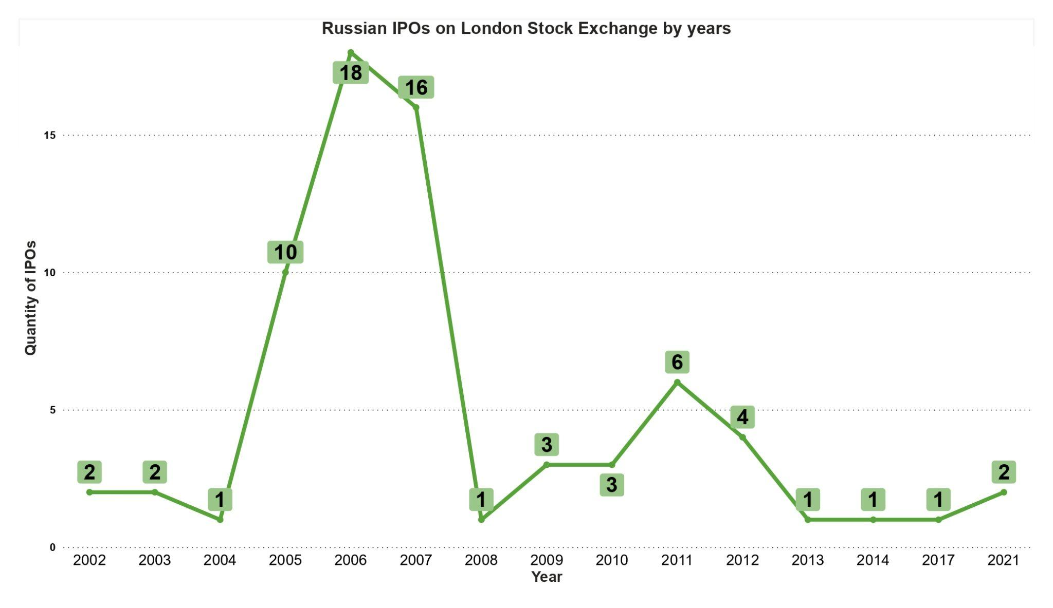
Figure 1. Russian IPOs on LSE from 2000-2025.
source: compiled by the authors

He read the letters. One was very unpleasant (see Figure 1), from a merchant who was buying a forest on his wife’s property. To sell this forest was absolutely essen-tial; but at present, until he was reconciled with his wife, the subject could not be discussed [6]. The most unpleasant thing of all was that his pecuniary inter-ests should in this way enter into the question of his reconciliation with his wife. And the idea that he might be led on by his interests, that he might seek a reconciliation with his wife on account of the sale of the forest — that idea hurt him.
When he had finished his letters, Stepan Arkadyevitch moved the office-papers close to him, rapidly looked through two pieces of business, made a few notes with a big pencil, and pushing away the papers, turned to his coffee. As he sipped his coffee, he opened a still damp morning paper, and began reading it.
Stepan Arkadyevitch took in and read a liberal paper, not an extreme one, but one advocating the views held by the majority. And in spite of the fact that science, art, and politics had no special interest for him, he firmly held those views on all these subjects which were held by the majority and by his paper, and he only changed them when the majority changed them — or, more strictly speaking, he did not change them, but they imperceptibly changed of them-selves within him.
Stepan Arkadyevitch had not chosen his political opinions or his views; these political opinions and views had come to him of themselves, just as he did not choose the shapes of his hat and coat [7], but simply took those that were being worn. And for him, living in a certain society — owing to the need, ordinarily developed at years of discretion, for some degree of mental activity — to have views was just as indispensable as to have a hat. If there was a reason for his preferring liberal to conservative views, which were held also by many of his circle, it arose not from his considering liberalism more rational, but from its being in closer accordance with his manner of life. The liberal party said that in Russia everything is wrong, and certainly Stepan Arkadyevitch had many debts and was decidedly short of money. The liberal party said that marriage is an in-stitution quite out of date, and that it needs reconstruction; and family life cer-tainly afforded Stepan Arkadyevitch little gratification, and forced him into lying and hypocrisy, which was so repulsive to his nature [8]. The liberal party said, or rather allowed it to be understood, that religion is only a curb to keep in check the barbarous classes of the people; and Stepan Arkadyevitch could not get through even a short service without his legs aching from standing up, and could never make out what was the object of all the terrible and high-flown language about another world when life might be so very amusing in this world. And with all this, Stepan Arkadyevitch, who liked a joke, was fond of puzzling a plain man by saying that if he prided himself on his origin, he ought not to stop at Rurik and disown the first founder of his family — the monkey. And so Liber-alism had become a habit of Stepan Arkadyevitch’s, and he liked his newspaper, as he did his cigar after dinner, for the slight fog it diffused in his brain. He read the leading article, in which it was maintained that it was quite senseless in our day to raise an outcry that radicalism was threatening to swallow up all con-servative elements, and that the government ought to take measures to crush the revolutionary hydra; that, on the contrary, "in our opinion the danger lies not in that fantastic revolutionary hydra, but in the obstinacy of traditionalism clogging progress," etc., etc. He read another article, too, a financial one, which alluded to Bentham and Mill, and dropped some innuendoes reflecting on the ministry. With his characteristic quickwittedness he caught the drift of each in-nuendo, divined whence it came, at whom and on what ground it was aimed, and that afforded him, as it always did, a certain satisfaction. But today that satisfaction was embittered by Matrona Philimonovna’s advice and the unsatis-factory state of the household. He read, too, that Count Beist was rumored to have left for Wiesbaden, and that one need have no more gray hair, and of the sale of a light carriage, and of a young person seeking a situation; but these items of information did not give him, as usual, a quiet, ironical gratification [9]. Having finished the paper, a second cup of coffee and a roll and butter, he got up, shaking the crumbs of the roll off his waistcoat; and, squaring his broad chest, he smiled joyously: not because there was anything particularly agreea-ble in his mind — the joyous smile was evoked by a good digestion.
Darya Alexandrovna, in a dressing jacket, and with her now scanty, once luxuriant and beautiful hair fastened up with hairpins on the nape of her neck, with a sunken, thin face and large, startled eyes, which looked prominent from the thinness of her face, was standing among a litter of all sorts of things scat-tered all over the room, before an open bureau, from which she was taking something. Hearing her husband’s steps, she stopped, looking towards the door, and trying assiduously to give her features a severe and contemptuous expression. She felt she was afraid of him, and afraid of the coming interview. She was just attempting to do what she had attempted to do ten times already in these last three days — to sort out the children’s things and her own, so as to take them to her mother’s — and again she could not bring herself to do this; but now again, as each time before, she kept saying to herself, "that things cannot go on like this, that she must take some step" to punish him, put him to shame, avenge on him some little part at least of the suffering he had caused her. She still continued to tell herself that she should leave him, but she was conscious that this was impossible; it was impossible because she could not get out of the habit of regarding him as her husband and loving him [10]. Besides this, she realized that if even here in her own house she could hardly manage to look after her five children properly, they would be still worse off where she was going with them all. As it was, even in the course of these three days, the youngest was unwell from being given unwholesome soup, and the others had almost gone without their dinner the day before. She was conscious that it was impossible to go away; but, cheating herself, she went on all the same sorting out her things and pretending she was going.

References

- The complementarity between tax avoidance and manager diversion: evidence from tax haven firms / T. J. Atwood, C. Lewellen // Contemporary Accounting Research. – 2018. – Vol. 36, no. 1. – P. 259–294.
- Соболева, И. В. Особенности женской занятости в свете мирового тренда продвижения гендерного равенства / И. В. Соболева. – URL: https://cyberleninka.ru/article/n/osobennosti-zhenskoy-zanyatosti-v-svete-mirovogo-trenda-prodvizheniya-gendernogo-ravenstva/pdf (дата обращения: 17.02.2021). – Текст : электронный.
- Pathological and therapeutic effects of extracellular vesicles in neurological and neurodegenerative diseases / P. Izquierdo-Altarejos, V. Moreno-Manzano, V. Felipo // Neural Regeneration Research. – 2024. – Vol. 19, no. 1. – P. 55–61.
- Foucault, M. Le discours philosophique : hautes études / M. Foucault, F. Ewald, O. Irrera, D. Lorenzini. – Paris : EHESS : Gallimard : Seuil, 2023. – 305 p.
- DeLancey, L. The impact of responsibility center management on academic libraries: an exploratory study / L. DeLancey, S. deVries // Portal: Libraries and the Academy. – 2023. – Vol. 23, no. 1. – P. 7–22.
- Свод знаний по управлению бизнес-процессами BPM CBOK 4.0 / Т. Бенедикт, М. Кирхмер, М. Шарсиг [и др.]. – Москва : Альпина Паблишер, 2022.
- Arbitrary-order derivatives of quantum chemical methods via automatic differentiation / A. S. Abbott, B. Z. Abbott, J. M. Turney, H. F. Schaefer // The Journal of Physical Chemistry Letters. – 2021. – Vol. 12, no. 12. – P. 3232–3239.
- A framework for pandemic prediction using big data analytics / I. Ahmed, M. Ahmad, G. Jeon, F. Piccialli // Big Data Research. – 2021. – Vol. 25. – P. 100190.
- Aljawarneh, S. Data science for analyzing and improving educational processes / S. Aljawarneh, J. A. Lara // Journal of Computing in Higher Education. – 2021. – Vol. 33, no. 3. – P. 545–550.
- A framework for pandemic prediction using big data analytics / I. Ahmed, M. Ahmad, G. Jeon, F. Piccialli // Big Data Research. – 2021. – Vol. 25. – P. 100190.

